700106 / 700120 Lab Book

Vulkan Exercises

Exercise 1: PREPARING THE APPLICATION FOR TEXTURES
Solution&Reflection: Prepared the Vulkan application to support texture mapping. I started by downloading and integrating the stb_image.h library, which allows the program to load image files as textures. To enable the implementation, I defined STB_IMAGE_IMPLEMENTATION in one of the C++ source files before including the header. Next, I added a sample texture (a simple image file) to the project’s build directory so the program could access it during runtime. The Vertex structure was updated to include a glm::vec2 texCoord attribute, allowing each vertex to store UV coordinates that map the texture correctly to the 3D model. I also modified the vertex input descriptions to account for this new attribute, ensuring Vulkan interprets the texture coordinates properly. Finally, I updated the cube’s vertex data to include UV mappings for all six faces, assigning appropriate coordinates in the [0,1] range to make the texture appear correctly on each side.
This task helped me understand how texture coordinates relate to vertex data and how shaders use them to map 2D images onto 3D geometry. It also clarified how libraries like stb_image simplify texture loading.
Question: When defining UV coordinates for complex models, is there an efficient or automated way to generate them, or is manual assignment (like with the cube) still common practice in small projects?
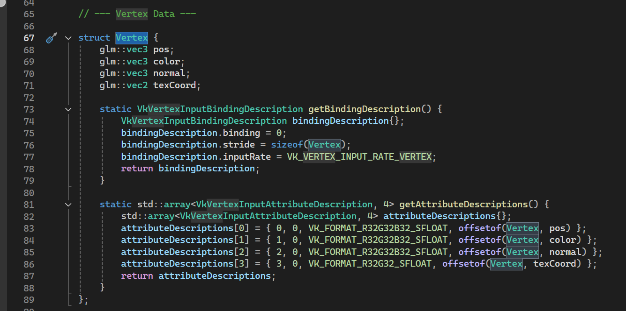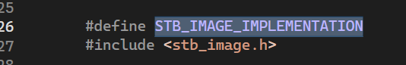
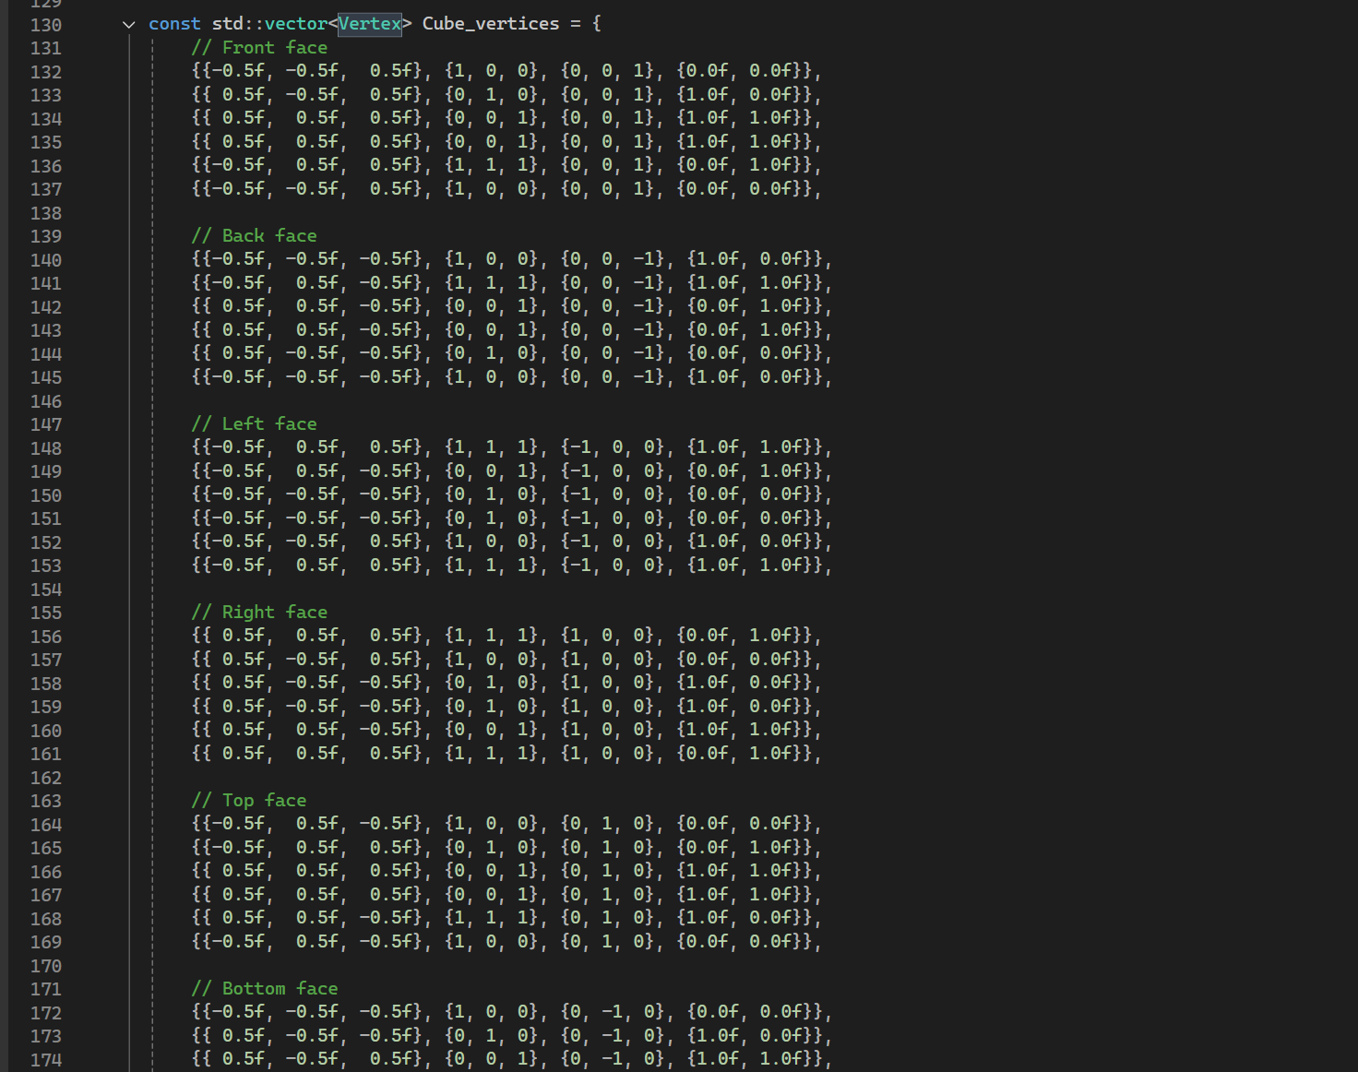

Exercise 2: LOADING AND CREATING VULKAN IMAGE RESOURCES
Solution&Reflection: I implemented the process of loading an image file and preparing it as a usable texture within Vulkan. First, I declared the necessary Vulkan objects — the VkImage, VkDeviceMemory, VkImageView, and VkSampler — to store and reference the texture data. Using the stb_image library, I loaded the texture file into memory and calculated its size in bytes. Next, I created a staging buffer, which temporarily holds the image data on the CPU side. After mapping and copying the pixel data into this buffer, I freed the original CPU image memory to optimize resources. I then created a VkImage on the GPU with the appropriate format (VK_FORMAT_R8G8B8A8_SRGB) and allocated device-local memory to store it efficiently for rendering. The next step involved recording and submitting command buffers to handle layout transitions and copy operations — moving the texture from the staging buffer to the GPU image and changing its layout to be readable by shaders. Once the transfer was complete, I cleaned up the staging resources. Finally, I created an image view and sampler, which define how the texture will be accessed and filtered in the fragment shader, allowing for smooth, repeated texture mapping across surfaces.
Through this process, I gained a deeper understanding of how Vulkan handles image data and memory management. The staged copy and layout transition steps, while complex, demonstrated Vulkan’s low-level control over GPU resources and synchronization. Setting up the sampler also clarified how filtering and anisotropy affect texture quality during rendering.
Question : Could you elaborate on how Vulkan’s layout transitions differ from OpenGL’s implicit state changes, and why explicit transitions are considered advantageous in modern rendering pipelines?
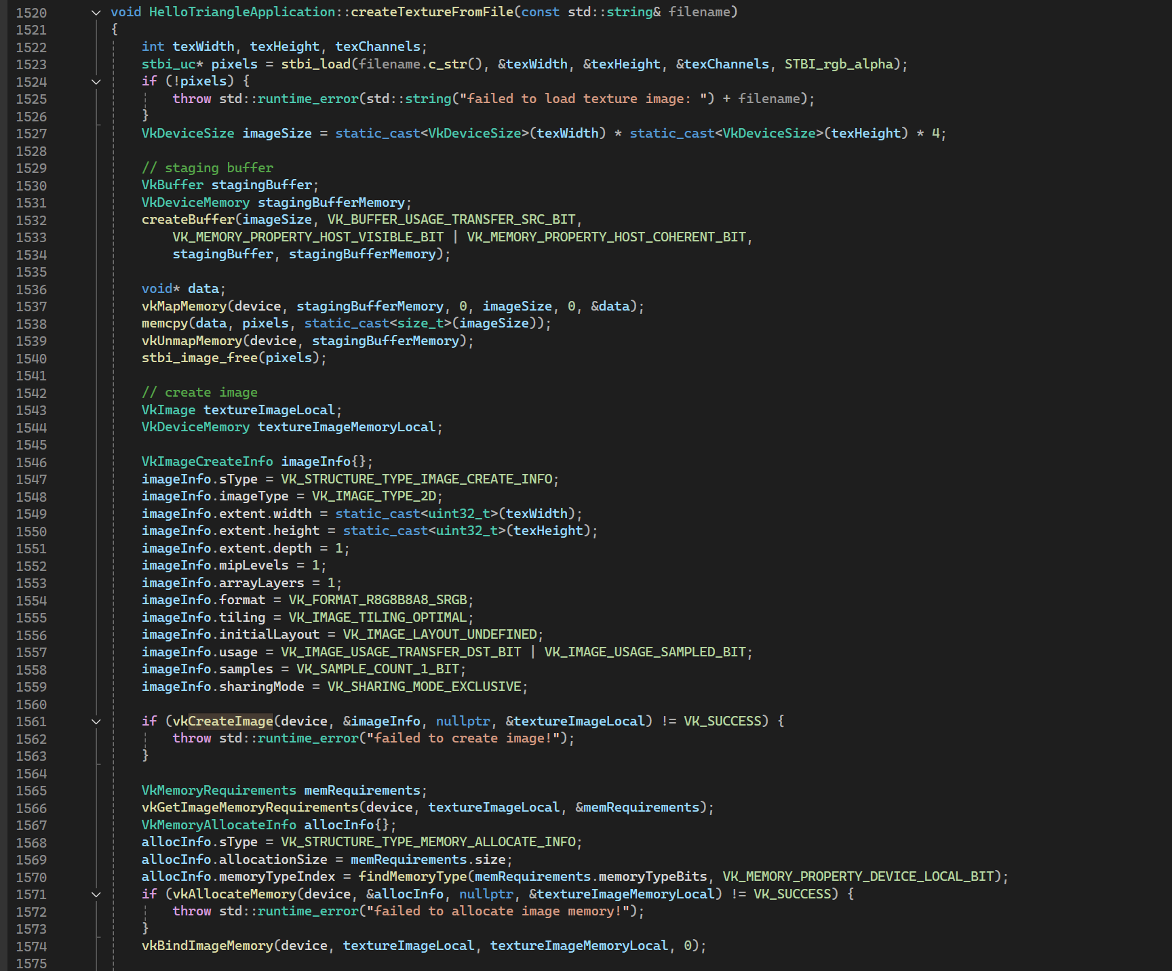
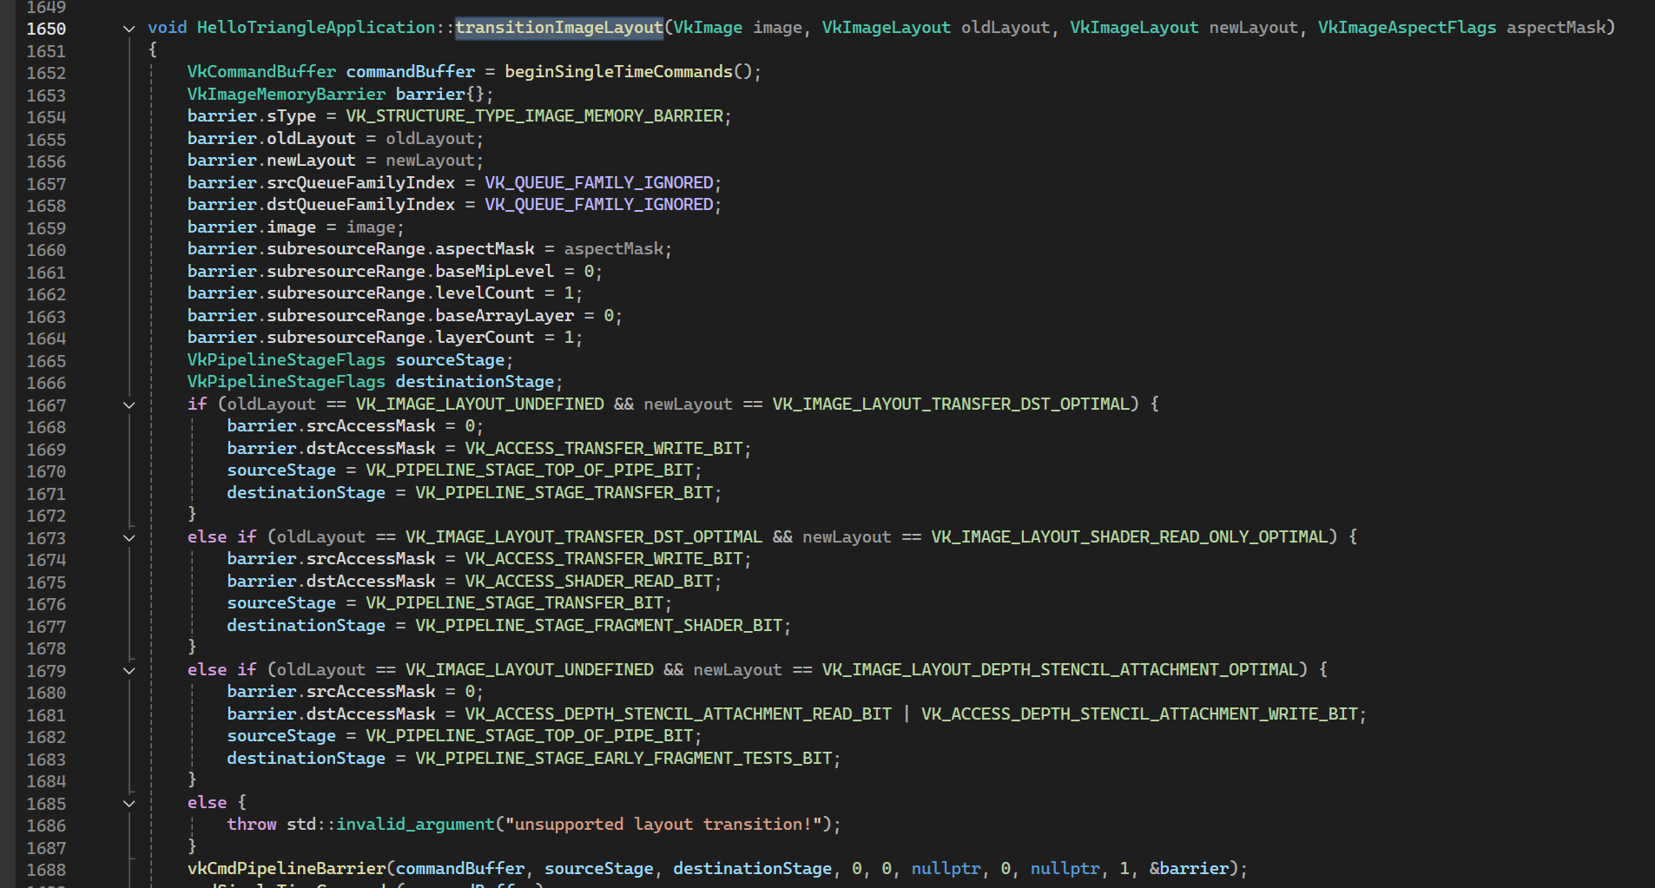

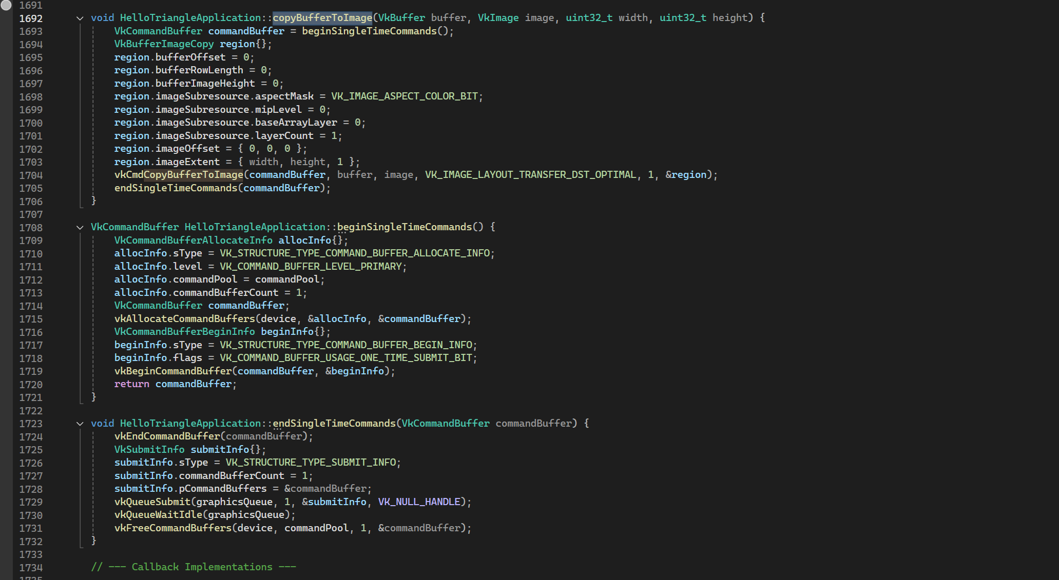

Exercise 3: BINDING AND SHADER UPDATES
Question: Improve visual quality by moving the lighting logic to the fragment shader, allowing for smoother, more accurate calculations.
Solution: Integrated texture sampling into the Vulkan rendering pipeline by updating descriptor bindings and modifying the shaders. First, I extended the descriptor set layout to include a new binding for a combined image sampler, allowing the fragment shader to access texture data. I then updated the descriptor pool to allocate space for this new descriptor type and modified the descriptor set creation process to include both the uniform buffer (binding = 0) and the texture sampler (binding = 1). This required setting up a VkDescriptorImageInfo structure that linked the texture image view and sampler created in the previous exercises. After ensuring the descriptor set layout included both bindings, I updated the cleanup routines to properly release these texture resources, avoiding potential memory leaks. I also added the texture setup calls to initVulkan() so that all texture resources were prepared before rendering.
Next, I modified the vertex and fragment shaders to support texture coordinates and sampling. In the vertex shader, I introduced a new input for the texture coordinates and passed it to the fragment shader. The fragment shader was then updated to include a sampler2D uniform and to sample the texture using the interpolated coordinates. The final color output combined the sampled texture color with existing lighting calculations to create a more realistic, lit, textured cube.

Question: When working with multiple textures or material types in a single scene, would it be more efficient to use a single descriptor set with multiple bindings, or to create separate descriptor sets per material or object?
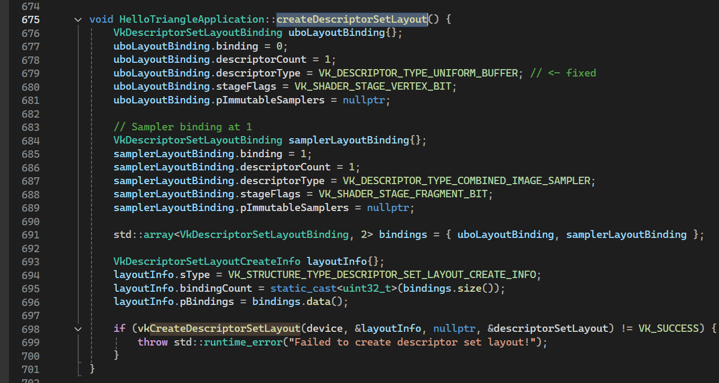
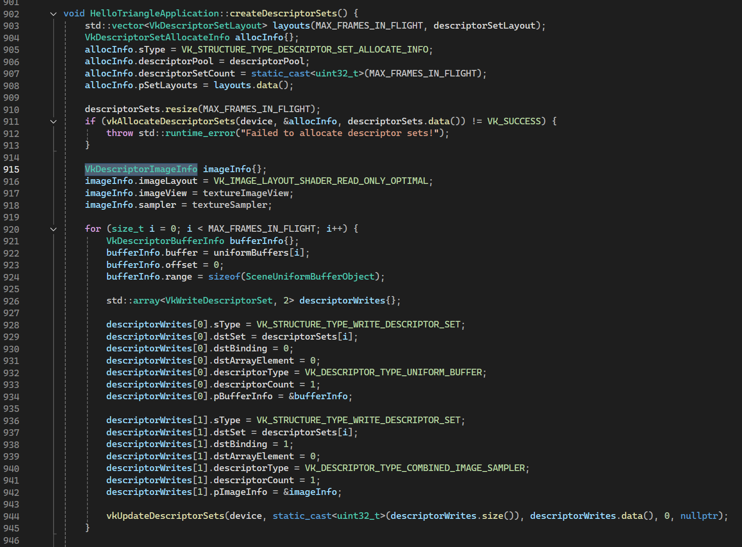
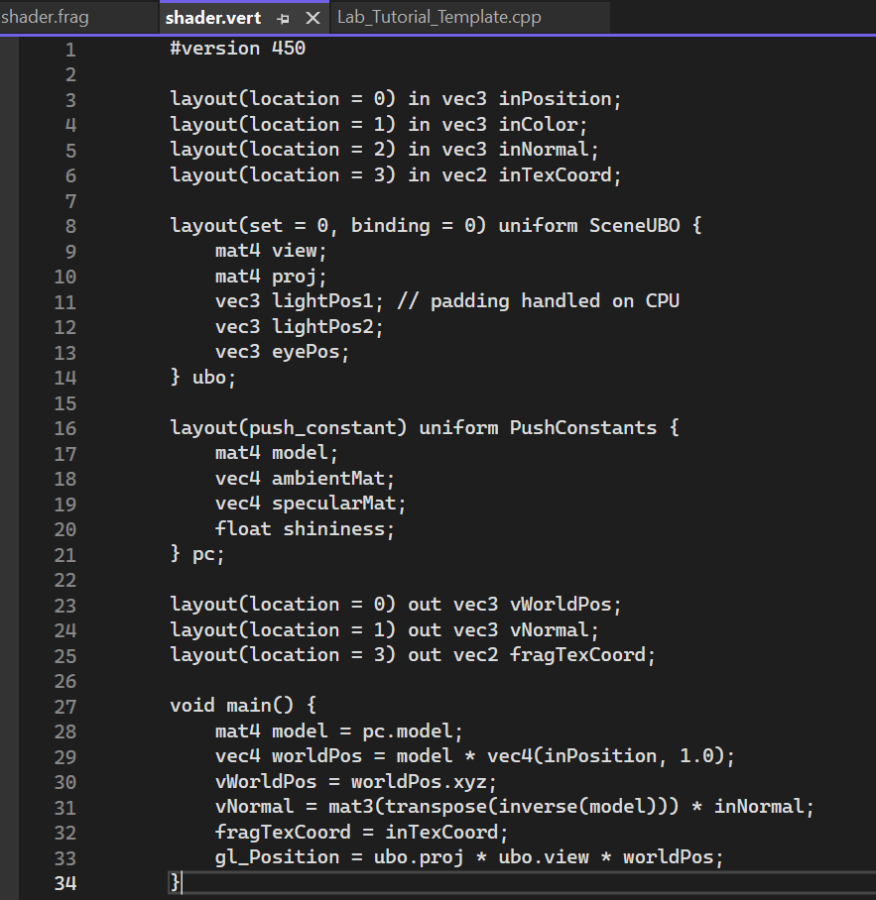
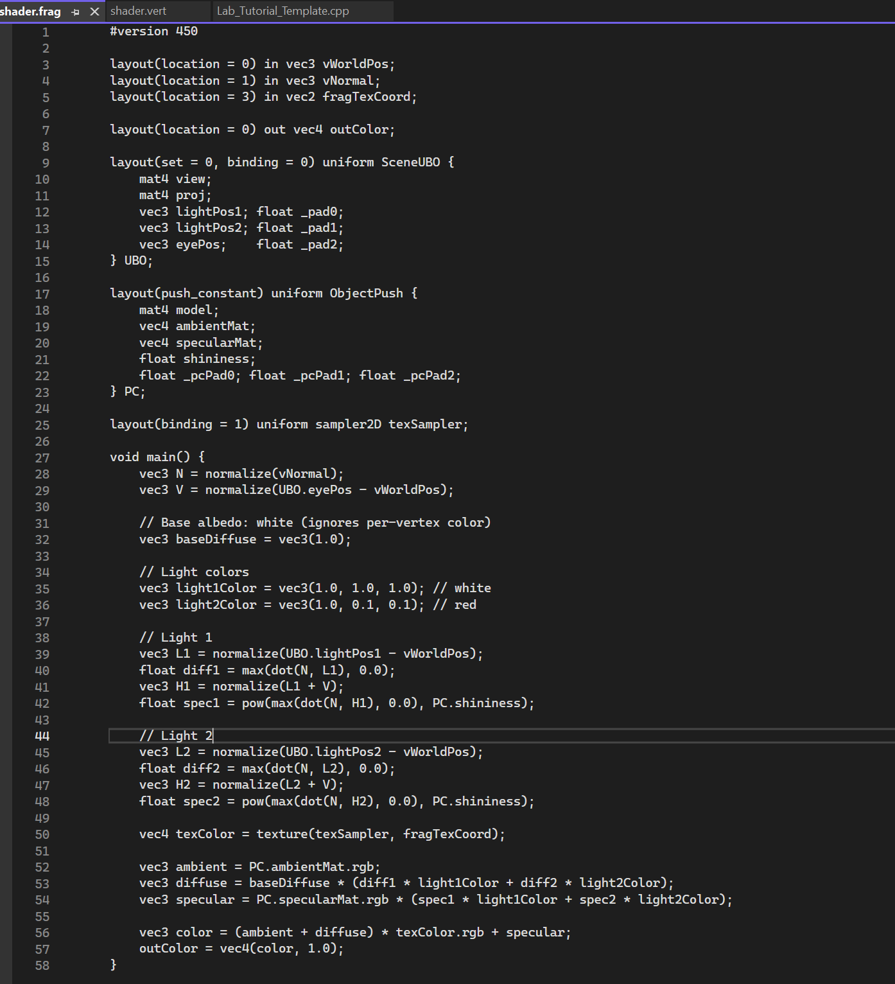

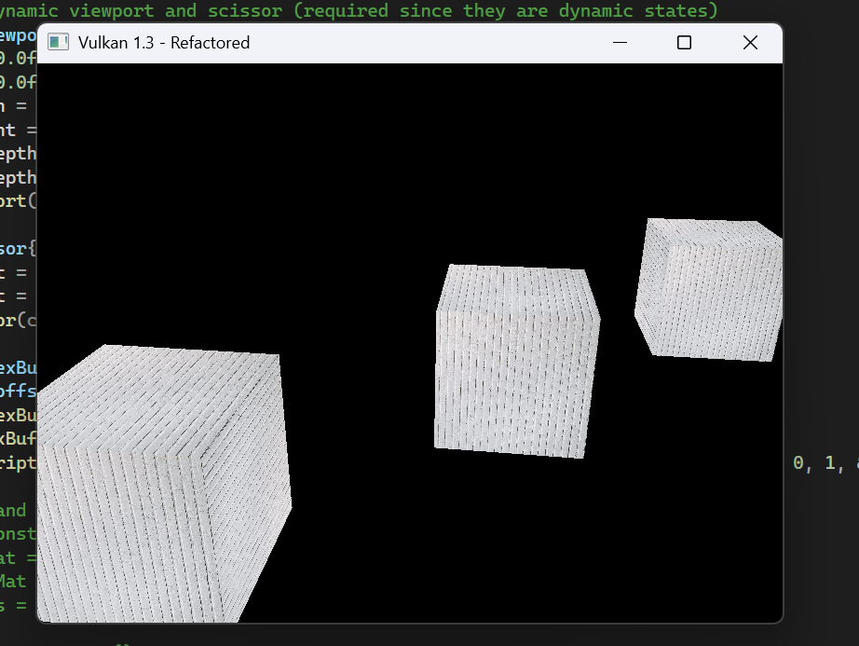

Exercise 4: A WOODEN CUBE
Solution: Replaced the existing texture in the Vulkan application with a new wood texture to create a more realistic, wooden appearance for the cube. The process began by converting the provided wood.dds texture file into a more commonly supported JPEG format (wood.jpg) using an online texture converter. Once converted, I replaced the previous texture.jpg file in the project with the new wood texture and ensured that the application loaded it correctly. In the rendering pipeline, I modified the fragment shader from the previous per-fragment lighting implementation so that the cube’s surface color now comes directly from the wood texture instead of the vertex color attribute. This adjustment allowed the texture to interact with the lighting model, producing visually realistic shading, highlights, and wood grain detail across the cube’s surfaces.
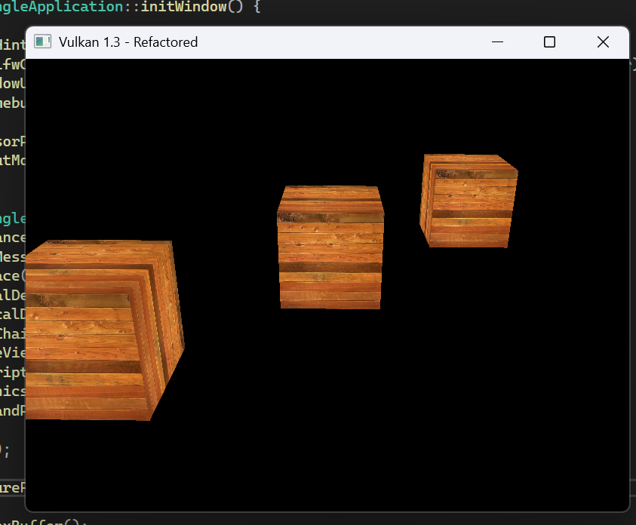
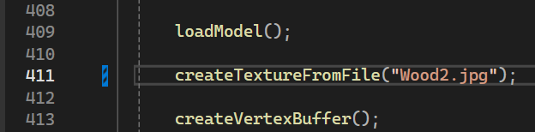

Exercise 5: TEXTURE WRAPPING MODE
Solution & Reflection: I implemented a textured cube using the Coin.jpg texture, experimenting with different texture wrapping modes and UV scaling to display varying numbers of coin patterns on each cube face. To achieve this, I introduced a small lambda function auto faceUV = [&](float S, glm::vec2 uv) { return uv * S; }; that scales the texture coordinates (uv) by a specified factor S. This allowed each face of the cube to have independent control over how many times the texture repeats. For example, I used faceUV(1.f, uv) on the front face for a single coin pattern, while the back face used faceUV(2.f, uv) to repeat the texture twice. Because the texture sampler was configured with VK_SAMPLER_ADDRESS_MODE_REPEAT, any UV coordinates outside the [0,1] range caused the texture to wrap and tile seamlessly. The result was a cube where each side displayed a different number of repeated coin textures, clearly demonstrating how UV scaling and texture wrapping interact in Vulkan.

Question: If we wanted to apply different wrapping modes (e.g., CLAMP_TO_EDGE or MIRRORED_REPEAT) to individual faces of a model, would that require multiple samplers and descriptor bindings, or can it be achieved using a single texture and shader logic?
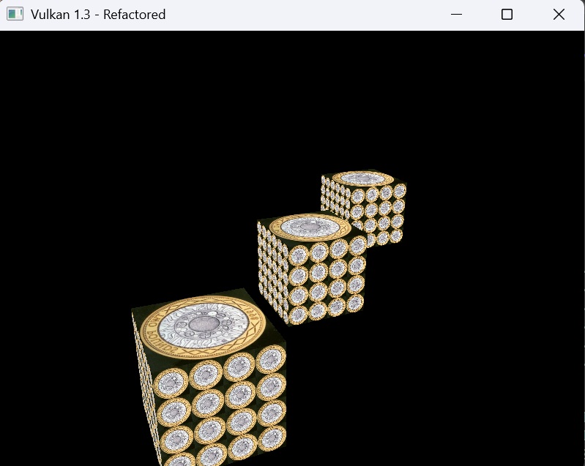

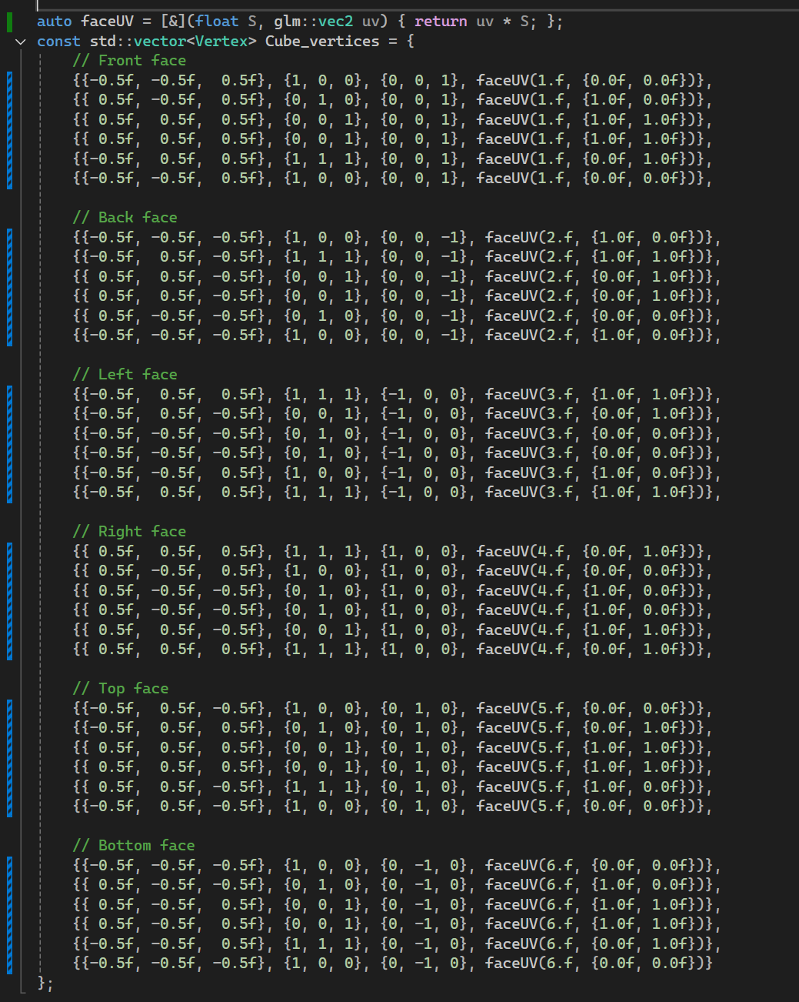

Exercise 6: TEXTURE FILTERING TECHNIQUES
Solution: I implemented real-time filter switching within the processInput() function. By pressing keys 1–4, the user can toggle between nearest-neighbour, bilinear, anisotropic, and bicubic filtering modes. This was achieved by defining a textureFilterMode variable that updates based on input, allowing the rendering pipeline to apply the corresponding sampler configuration. This interactivity made it easy to visually compare how each filtering mode handles minification and magnification.
Through observation, nearest-neighbour filtering produced a pixelated look, especially at shallow viewing angles. Bilinear filtering offered smoother results but introduced slight blurriness under large-scale minification. Bicubic filtering improved smoothness further, providing more natural gradients. However, the most visually effective was anisotropic filtering, which preserved detail along the elongated road and reduced stretching artifacts, demonstrating why it is widely used in 3D graphics for textured surfaces viewed at oblique angles.
This exercise reinforced the critical role of texture filtering in maintaining visual fidelity and realism in real-time rendering. It also showed how user-controllable filtering settings can be valuable for testing and optimizing graphical quality versus performance trade-offs.

Question: When implementing dynamic filter switching in more complex engines, is it common practice to re-create samplers at runtime, or are multiple preconfigured samplers typically bound and switched through descriptor updates for performance reasons?

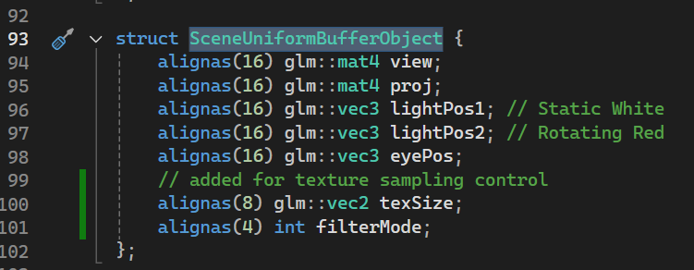
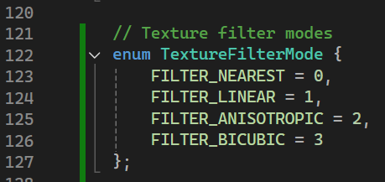
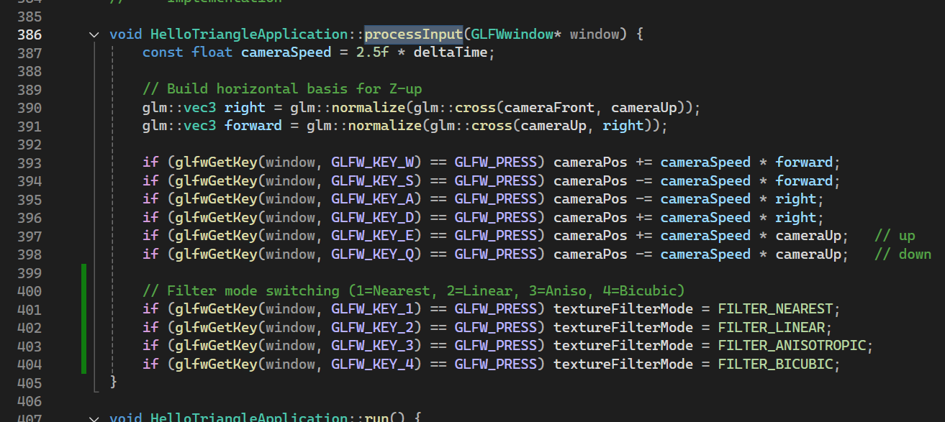
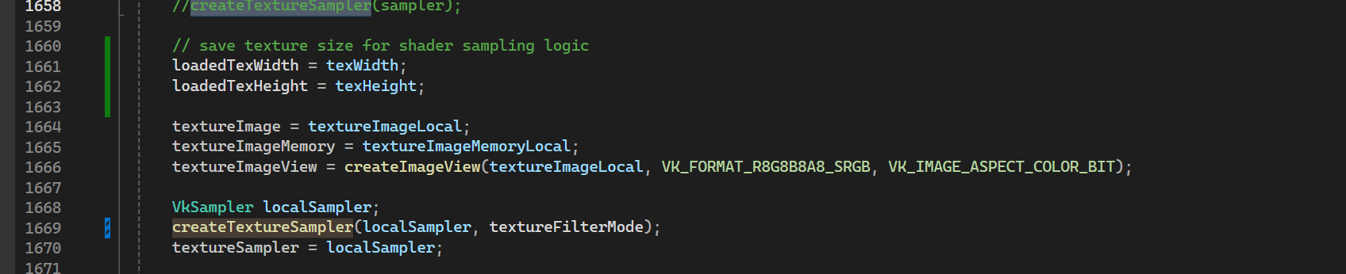
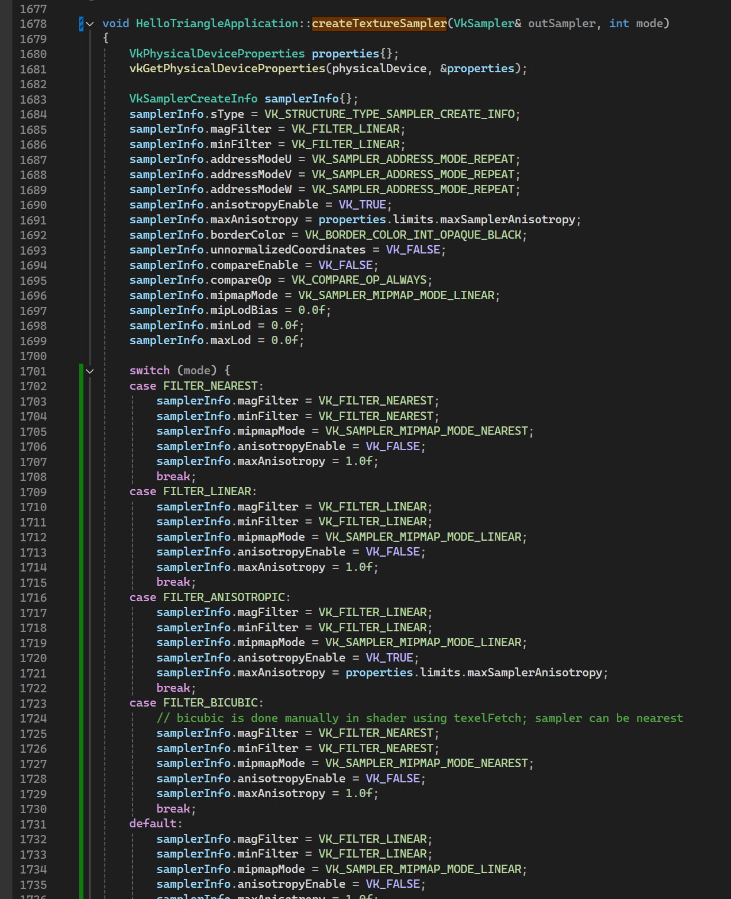

FILTER_NEAREST:
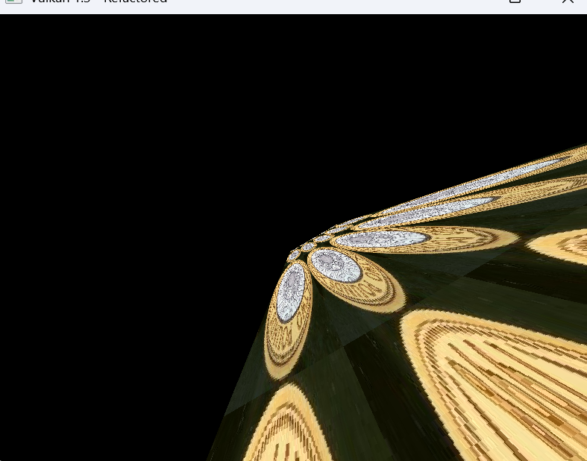

FILTER_LINEAR:
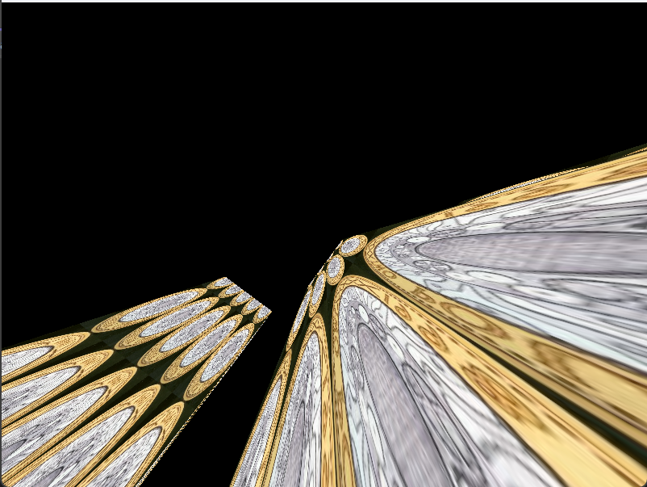

FILTER_ANISOTROPIC:
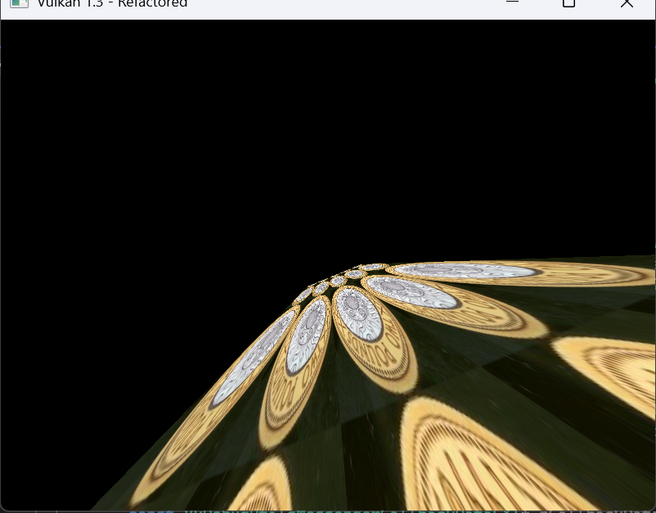

FILTER_BICUBIC:
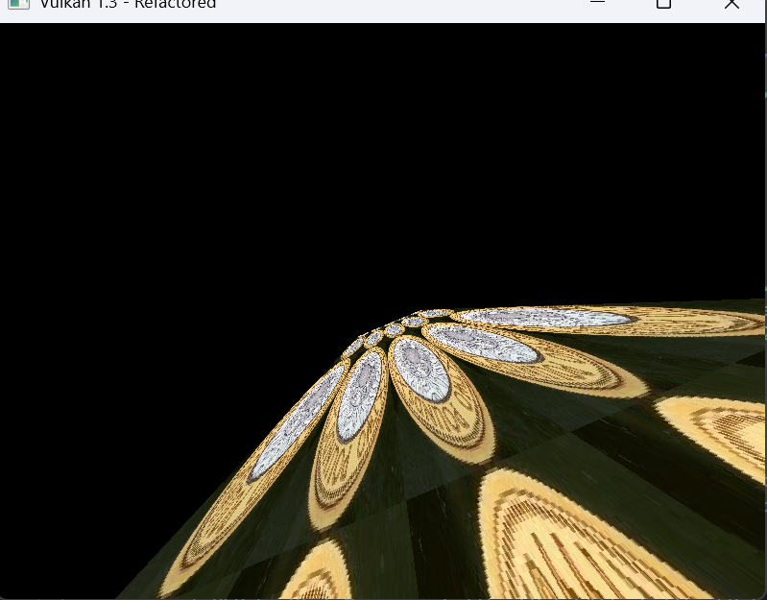

EXERCISE 7. MULTIPLE TEXTURING
Solution & Reflection: This exercise demonstrated how multiple texture sampling can enhance surface realism by combining patterns or overlays.
It also shows how easily shaders can be extended to use multiple samplers by adding descriptor bindings.
Blending approaches (mix, multiply, add) each yield different visual results depending on desired style (e.g., roughness maps, decals, albedo overlays).

Question: How does Vulkan handle performance when sampling multiple textures per fragment — is there a limit or best practice?
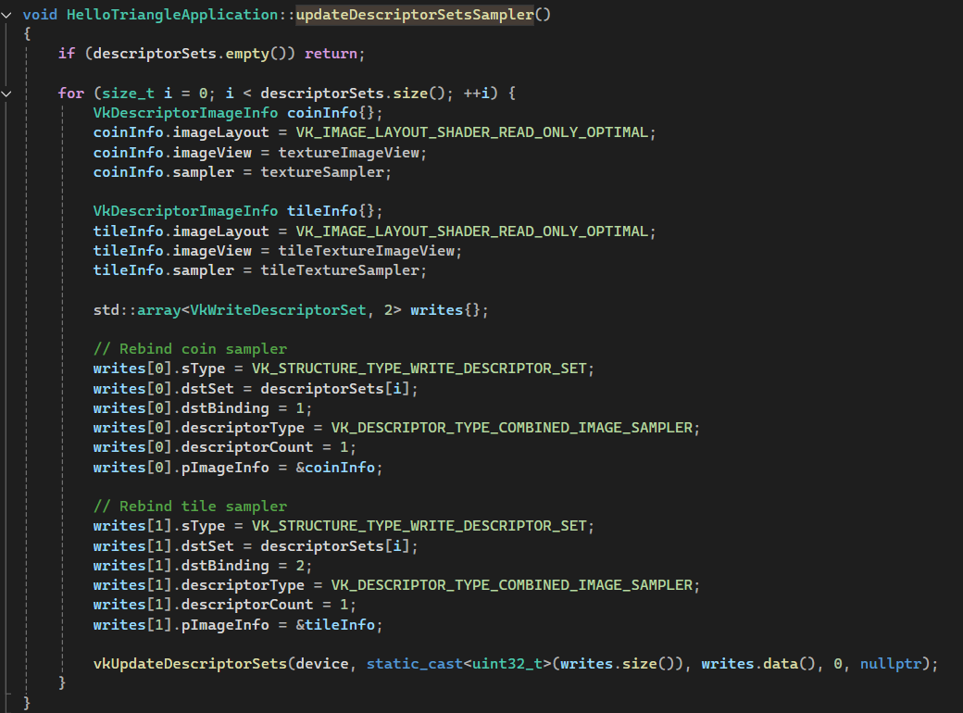
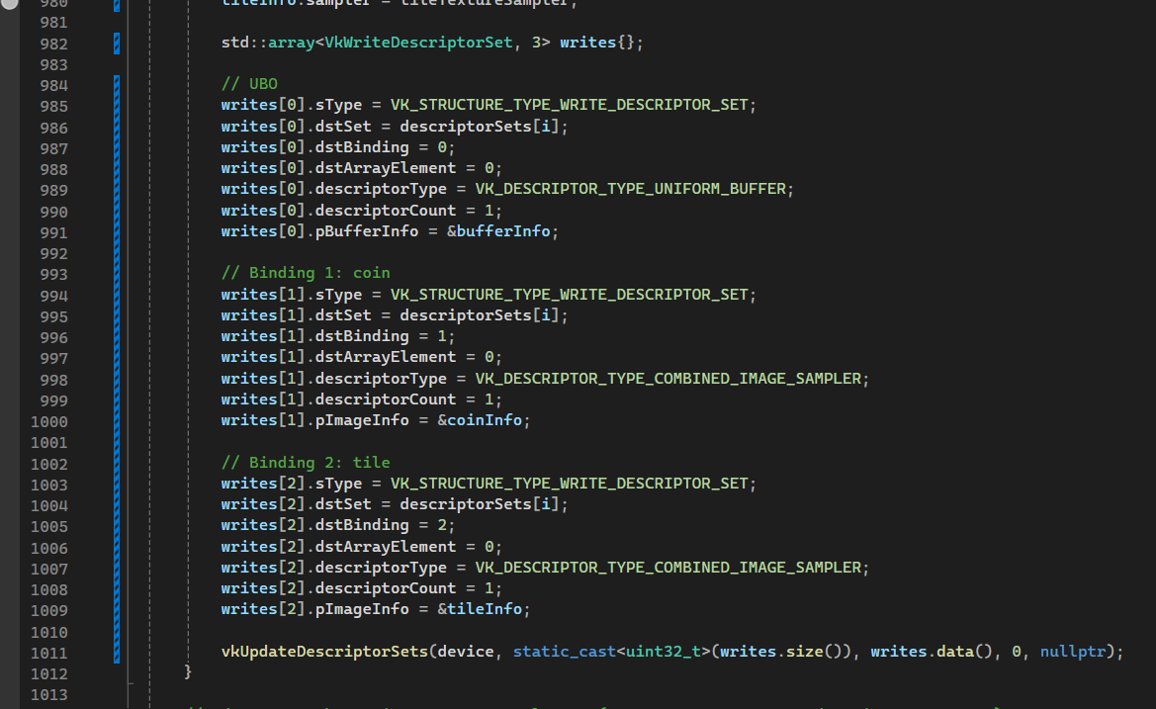
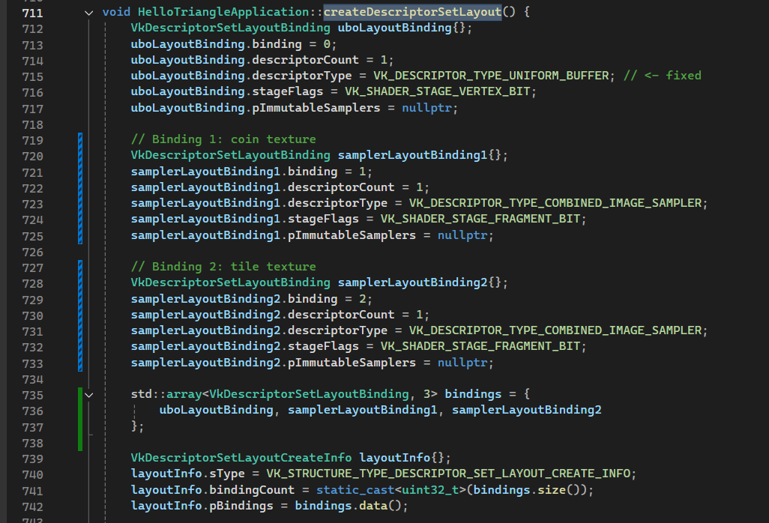
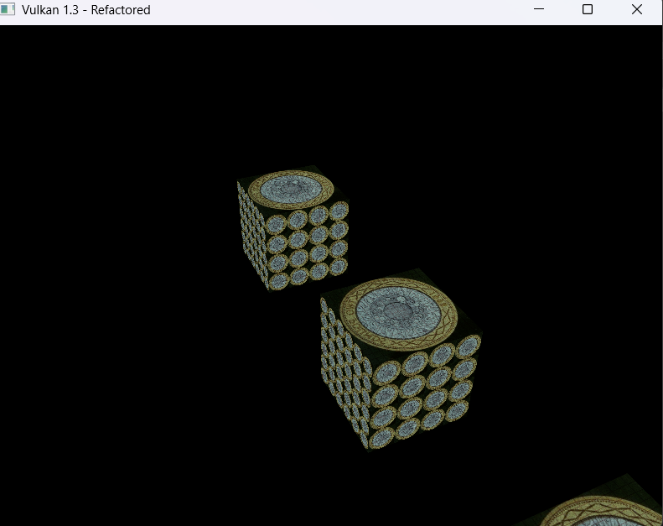

EXERCISE 8. AN OPEN BOX
Solution & Reflection: This exercise involved creating a single open-topped box with different textures on the inside and outside: rock on the exterior and wood on the interior. This was a multi-stage process that involved fixing several fundamental rendering issues.
First, to create the "open" effect, I modified the draw command in recordCommandBuffer. Instead of drawing all 36 indices, I used two separate vkCmdDrawIndexed calls: one to draw the first 24 indices (the four side faces) and a second to draw the last 6 indices (the bottom face), specifically skipping the 6 indices corresponding to the top face.
Second, to make the internal faces visible, I had to disable back-face culling. By default, the GPU culls the "inside" of triangles. I disabled this in createGraphicsPipeline by setting rasterizer.cullMode = VK_CULL_MODE_NONE;.
With the inside visible, the core challenge was applying two different textures to the same object. I achieved this in the fragment shader by using the built-in gl_FrontFacing variable. The shader logic checks this boolean: if true (the pixel is on an outside face), it samples the tileTex (rock); if false (an inside face), it samples the mainTex (wood).
This implementation immediately revealed two major bugs:
- Winding Order: The gl_FrontFacing logic failed on some faces. This was because the provided Cube_vertices data had inconsistent winding order (some faces were Clockwise, some Counter-Clockwise), which "tricked" the shader. I had to manually edit the Cube_vertices array to ensure all faces were defined with a consistent Counter-Clockwise (CCW) winding order.
- Depth (Z-Fighting): The box rendered with severe graphical glitches, with the far inside walls drawing on top of the near outside walls. This was because the application lacked a depth buffer.
To solve this, I implemented a full depth-stencil buffer. This required creating a depthImage, depthImageMemory, and depthImageView. I then updated createGraphicsPipeline to include a VkPipelineDepthStencilStateCreateInfo struct, enabling both depthTestEnable and depthWriteEnable. Finally, in recordCommandBuffer, I attached the depthImageView to the VkRenderingInfo struct as the pDepthAttachment. This also introduced an initialization crash, which I fixed by moving the createCommandPool() call to an earlier point in initVulkan(), ensuring the command pool existed before createDepthResources was called.
This exercise was a practical demonstration of how culling, shader logic (gl_FrontFacing), vertex data (winding order), and the depth buffer are all critically interconnected for correct 3D rendering.

Question: Using gl_FrontFacing works well here, but it feels like a special case. For a complex model that requires a "two-sided" material (like a piece of cloth or paper), is checking gl_FrontFacing in the shader the standard, efficient method? Or do rendering engines prefer to use two separate draw calls (one with VK_CULL_MODE_FRONT_BIT and one with VK_CULL_MODE_BACK_BIT), or even just duplicate the geometry with flipped normals?

